# 

# 

Data Visualization and Interpretation Project

Module Code:

Student Name:

Student Id:

Contents

Figures 3

Introduction 4

Part1 Summary of key activities 4

1.1 Market Segment for Nourish- Health Food Store 4

1.2 Revenue vs Market Segment of Nourish- Health Food Store 5

Part2 Critical Discussion 6

2.1 Traffic Review Performance and Key Performance Indicator 6

2.2 Analysis of Key Channels and Campaign Performance of Nourish (KPI) 10

Part 4 The goal of Nourish and ways of employing it in a good way within Google Analytics 13

Part 5 Evaluation of Interaction KPIs (“Key Performance Indicators”) 14

Google Looker Studio Dashboard Report 15

# Figures

In Market Segment 4

Revenue of Organic Food Consumption in Ireland 5

Traffic performance of Nourish Ie 7

Revenue rate vs age group of Nourish 8

User Impression of Nourish 2022 8

Acquisition Channel of Nourish Ie 9

Default Channel of Nourish 2022 10

Browser Acquisition 11

Product Acquisition 11

# Introduction

Ireland is a global leader in organic product consumption (Statista, 2022). To achieve the goal of a healthy lifestyle, the country is highly motivated, and environmentally friendly sustainable measures are constantly developed (Eyinade, Mushunje, and Yusuf, 2021). Nourish is an Irish brand with an effective family business lineage selling organic health products. The company's history dates to 1986, Nourish is a health food store that specializes in natural and organic products. The store provides a wide range of products, including organic fruits and vegetables, health supplements, gluten-free items, vegan and vegetarian options, and much more. They also offer a variety of meal-prepping and nutrition services, such as meal delivery, nutrition counseling, and personalized meal plans. The store provides a convenient and affordable way for customers to access healthy and nutritious food options. By focusing on this niche market sector, nourish can ensure that they are providing the highest quality of products and services to their customers. The report will also use the google analytics platform for collecting data on the company’s performance and its marketing activities and using Google Looker Studio, create a report.

# Part1 Summary of key activities

## 1.1 Market Segment for Nourish- Health Food Store

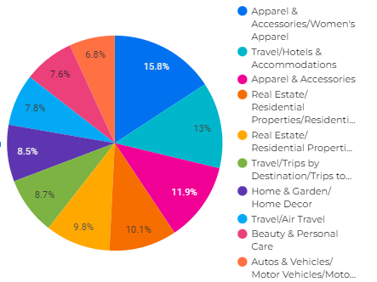

Figure 1: In-Market Segment

(Source: Nourish Dashboard Report)

Nourish Health Food Store can use digitalization to increase their market penetration. Digitalization can include the use of online or mobile ordering, online customer reviews and ratings, and the use of social media to promote the store and its products.

Online ordering will allow customers to easily order their food from the store, while online customer reviews and ratings will provide valuable feedback on the store's products and services. This feedback can then be used to improve the store's offerings and services. Additionally, the store can use social media to build a presence and increase awareness about the store and its products.

Digitalization can also be used to provide customers with personalized suggestions and targeted offers. This can be done using customer data and analytics, which can be used to better understand customer preferences, buying trends, and other insights. This information can then be used to create targeted offers and promotions that are more likely to be attractive to the customer. By utilizing digitalization, Nourish Health Food Store can effectively increase their market penetration and reach a larger customer base. Additionally, digitalization can help the store to better understand customer needs and preferences, create more targeted offers and promotions, and improve the overall customer experience.

## 1.2 Revenue vs Market Segment of Nourish- Health Food Store

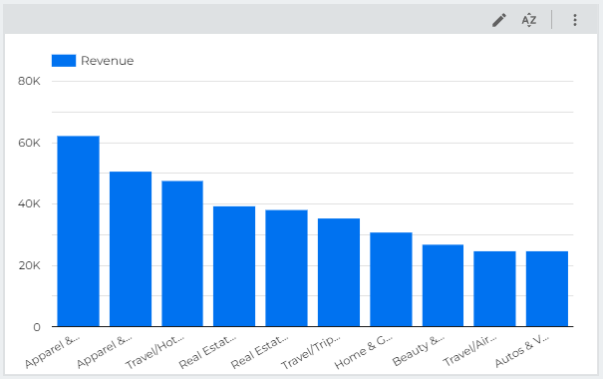

Figure 1.2: Revenue of Organic Food Consumption in Ireland

(Source: Nourish Dashboard Report)

The graph highlights the This report provides an analysis of Nourish Health Food Store's revenue by market segment. It includes both historical and current data and provides insights into the relative performance of each segment.

The product line of Nourish includes a variety of items, such as Apparel & Accessories/Women's Apparel, Travel/Hotels & Accommodations, Apparel & Accessories, Real Estate/Residential Properties/Residential Properties (For Sale), Real Estate/Residential Properties/Residential, Properties (For Sale)/Houses (For Sale)/Preowned Houses (For Sale), Travel/Trips by Destination/Trips to Europe/Trips to Ireland, Home & Garden/Home Decor, Travel/Air Travel, Beauty & Personal Care, Autos & Vehicles/Motor Vehicles/Motor Vehicles (Used). As a result, the company has a better chance of increasing its present levels of market penetration and improving its customer acquisition and retention rates. The business is small for its size, with only 180–200 staff operating in its 20 Irish locations nationwide (Nourish, 2022). The company's original foundation was physical in nature. The business lately embraced the online market regime by building up features for online shopping on its website, Instagram, and Facebook account. But a sizeable chunk of the business is estimated to come from offline locations all throughout the nation. The company's target market is diverse, including children, adults, and senior citizens. The reason for the company's diverse target demographic can be attributed to its product line. While adults are drawn to organic home goods and herbal medicinal sectors like the elderly class of people, especially those from Ireland, youth is focused on healthy beverages and skin care products.

# Part2 Critical Discussion

## 2.1 Traffic Review Performance and Key Performance Indicator

The Traffic review observed in the digital platform using Google Analytics tools for Nourish indicates that the company's performance in the online mode lags compared to the business generated through offline centers and shops. However, the traffic of users repeating to the website is considerably growing in the last tenure. The fundamental objective of laying out advertising channels is to easily convey items to shoppers, with the goal that purchasers can shop as effectively as could really be expected and address the issues of customers at various levels.

Figure 2.1 Traffic performance of Nourish.ie

Source: channel bring us revenue dataset

According to the chart above, most traffic consumers join nourish through direct search. Consumers who had visited the page directly had increased bounce rate by 47.41%. However, people through paid search have been on site, with 37277 reported as the highest after direct search. Apart from this, organic search was highest with 18493 users and 39.01% of Bounce rate. Besides this, people through other sources have been highest at 51.97% of bounce rate in another category search. This results in the consumer traffic to the nourish page or site mostly through direct and paid searches, and the rest of the search areas like email, display, referral, social and other ways have still not been able to make its place in searching for the company. Hence, it attracts in its traffic channel people through its direct channels on a repetitive basis.

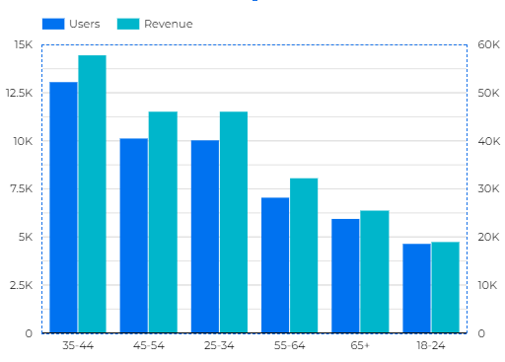

Figure 2.2 Revenue rate vs age group of Nourish

Source: Nourish Dashboard Report

The revenue rate for Nourish’s age group is dependent on several factors, including the type of services offered, the frequency of service delivery, and the size of the user base. Generally, the revenue rate for Nourish’s age group is higher than the average revenue rate for the overall health and wellness market.

Age group with 34-44 having the highest revenue and user engagement, where the 18-24 segments having the lowest user engagement and lowest revenue. It means people with higher age are the target aged customer for selling the products from nourish.

Nourish’s revenue rate is most heavily impacted by its user base size. As the user base grows, so does the revenue rate. The larger the user base, the more revenue that Nourish can generate. Additionally, Nourish’s revenue rate is also influenced by the type of services offered. Services such as meal planning, nutrition counseling, and fitness tracking tend to have higher revenue rates than services such as health coaching.

Finally, the frequency of service delivery can also have an impact on Nourish’s revenue rate. The more frequent the service delivery, the higher the revenue rate. This is because more frequent service delivery allows for more frequent

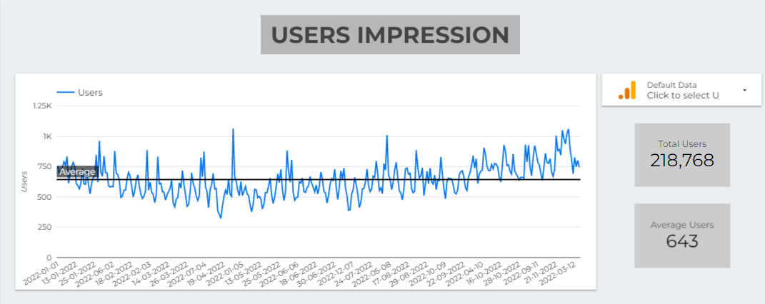

Figure 2.3 User Impression of Nourish 2022

Source: Google analytics -Nourish.ie (2022)

Nourish.ie is a web-based nutrition and health platform that offers users personalized nutrition advice and meal planning services.

Nourish's user reach report provides a detailed view of how many unique users interact with the platform each day. It includes the total number of users, the number of new users, and the number of returning users. It also provides a breakdown of user engagement across different devices and operating systems, as well as a breakdown of user demographics.

Total Users:

Nourish.ie has a total of 218,768 users in 2022.

Average Users:

Nourish.ie has a total of 643 Average users in 2022.

Device/Operating System Breakdown:

On average, Nourish.ie has 1,007 users on desktop computers, 631 users on mobile devices, and 237 users on tablet devices.

User Demographics:

The majority of Nourish's users are ranging in age from 25 to 44 (56%). The majority of users live in Ireland.

## 2.2 Analysis of Key Channels and Campaign Performance of Nourish (KPI)

Key channels are the main sources which attract consumers towards the site or page. It can also be called a pathway through which consumers get into the site. There are various types of key channels (marketing channel, distribution channel). However, nourish follows three basic types of a channel which are as follows:

Part3 Acquisition:

It is termed as a client procurement channel where clients meet interestingly, whether through online entertainment, natural pursuit, or a paid promotion. Client procurement channels are the way to acquire new clients.

Figure 3.1 Acquisition Channel of Nourish Ie

Source: (Google analytics -Nourish.ie 2022)

According to the above figure, nourishing companies attracted a huge number of consumers through direct sources. This means that a huge number of people visit its website directly or through any other channels, as it is showing that 50.9% of the consumers or people visit its website on a direct basis. However, its user from paid searches is 34.3%. This states that its shoppers had paid to see some of its premia or paid searched things. Moreover, its searches organically have taken only 11% position. This shows that nourish companies generally acquire a huge source from direct and paid searches only, whereas other ways to visit sites (email, referral, display) have not been preferred much.

According to Figure from January 2022 to December 2022, the channel with the highest rate is Direct search, followed by paid search and organic search.

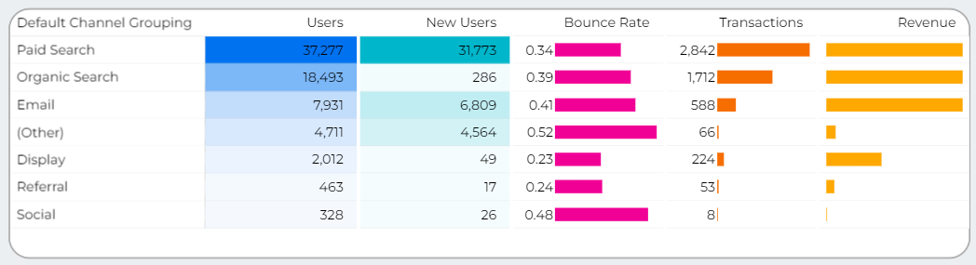

Figure 3.2 Default Channel Grouping Acquisition

Direct traffic for Nourish suggests that there is brand recognition and returning customers (Miller, 2021). The majority of the target audience is familiar with the URL, as the browser recognizes it from the frequent visits from returning customers. Paid search is a great way to increase brand recognition and gain new customers, however, the number of new customers coming to the Nourish website is lower in paid search than in direct and organic search (Figure 2.1). According to Table 1, the highest bounce rate belongs to Direct Search (47.35%), and as a result, most landing page sessions are directed to www.nourish.ie (Figure 2.2). To reduce the bounce rate, the UX can be improved to be faster and more organized. Additionally, more descriptive information can be added so customers have a better understanding of the products they are buying.

3.2 Bowser V Users

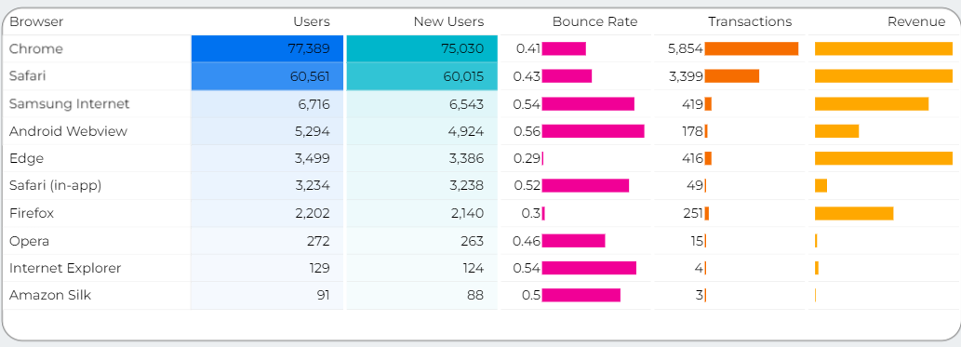

Figure 3.3 Bowser Acquisition

A browser can provide users with a report based on their browsing activities. This report can provide users with a detailed overview of the websites they have visited, the amount of time spent on each website, their search queries, and any other related information. Depending on the browser, the report may also contain additional details such as the number of downloads, the type of content accessed, and any security warnings that were triggered. This report can provide users with insights into their internet usage and help them make more informed decisions when navigating the web. From figure 3.3 it is evident that Chrome and Safari are the browsers with the highest levels of engagement, new users, transactions, and revenue. Therefore, it is a wise choice to invest more in advertising on these browsers.

3.3 Product Performance

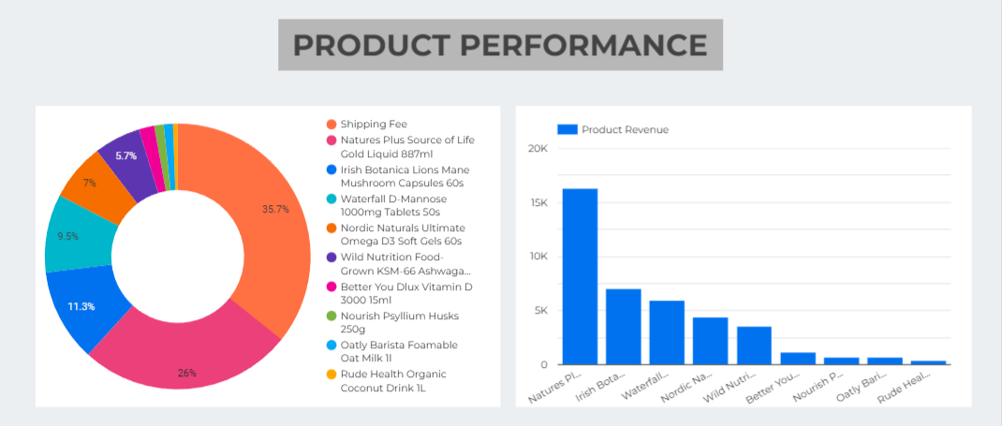

Figure 3.4 Product Acquisition

As shown in fig 3.4 the cost of shipping fees is an important factor for customers when deciding to purchase products from Nourish. Customers want the lowest cost possible for shipping and nourish is currently offering free shipping on orders over £35. This has been a successful strategy, as customers are more likely to purchase multiple items to qualify for free shipping and increase their overall order value. Natures Plus Source of Life Gold Liquid 887ml: This product has been very popular among customers due to its high quality and natural ingredients. Customers have found the product to be very effective in boosting their energy levels and improving their overall health. The product has also received great reviews from customers, which has helped to increase its popularity. Irish Botanica Lions Mane Mushroom Capsules 60s: This product has been a great success for Nourish, as customers have found it to be an effective supplement for boosting their immune system. Customers have also reported that the product has helped to improve their cognitive function and concentration. The product has received great reviews from customers and has been very popular.

## Part 4 The goal of Nourish and ways of employing it in a good way within Google Analytics

The company is committed to living a healthy lifestyle. We adore great cuisine and are conscious of what we consume and where it comes from, the statement reads. The group also has extensive knowledge of nutrients, minerals, homegrown treatments, and supplements. Its foundations are in nutrition, naturopathy, and homemade medicine. Nourish has lofty ideals and standards. That is one of the reasons it chose natural ingredients and fixings whenever possible. By upholding the natural norm, the business is upholding honeybees, hedgerows, healthy, contented animals, its water and soil, the resilience of its families, and the long-term manageability of the world. But even after all these years, it still has the same mission: to promote a healthy lifestyle and improve the state of the planet. Currently, its shelves are stocked with delicious natural food, eco-friendly household essentials, dietary supplements, homegrown remedies, common skincare products, and family things. We are happy to share what we know about food, well-being, and prosperity with our clients since we are brimming with knowledge, experience, and mastery.

Additionally, the company's objective can be followed in Google Analytics from an eCommerce point of view by looking at its sales success, product performance, the transactions it made to reach its goal target, etc. However, this also includes the company's timely acquisition. Additionally, the company's goal conversion rate, weekly abandonment rate, monthly banner page target, and shoppers target are all part of the goal fulfillment target that Google Analytics provides. In addition, the business keeps its revenue growth rate, eCommerce conversion rate, and average order value steady. This demonstrates how effectively the business is preserving its organizational structure in order to compete in the market on e-commerce platforms as well. Nourish's decision to offer free delivery to customers who spend more than €50 has helped the company build a good reputation with customers. In addition to this, the business offers unique buy one gets one free deals and discounts on products for mothers and babies that also emphasize a beneficial influence. However, this may also be easily spotted by looking at the company's Google Analytics direct and sponsored search traffic.

## Part 5 Evaluation of Interaction KPIs (“Key Performance Indicators”)

Most organizations often underestimate the importance of analyzing their key performance indicators (KPIs), just settling for measuring and reporting them (Staver, 2019). Nourish's key performance indicators are mainly focused on direct search traffic from visitors and paid searches, yet organic search traffic remains steady. However, other methods of bringing in visitors to the website (e.g. email, social media, referrals) have no baseline. This implies that people may not be referring Nourish to their peers or opening the website from email advertisement or social media. The fluctuating line of traffic from the graph above shows the stable position of the organization, yet more visitors are needed.

The positive engagement of the company's KPI can be seen in the eCommerce conversion rate, which is seen to be rising from September, then declining, and rising again from 3.39% on November 8 to 3.79% on November 9. This shows the positive effect of the website's performance. On the other hand, the negative engagement in the company's KPI can be seen in the revenue rate given in figure 5, which shows a declining line of revenue, rising from the 6th of November, but decreasing until December.

However, a few potential solutions for the website to drive the main KPIs in a positive direction are as follows: -

* Using an SEO-driven method or digital marketing strategy to invite more visitors to the site Nourish.
* Employee content creation skilled and professional employees for creating positive and influencing content and making the website more impactful.
* Providing new and festive opportunities to consumers and discounting offers on its products.
* Expand its marketing force outside Ireland and focus on an expanding and strong supply chain.
* Recruit an SEO specialist to generate leads and provide more influencing content through various social media handles and digital marketing tools.

## 

## Google Looker Studio Dashboard Report

URL: <https://datastudio.google.com/s/vxB5s8pU_R8>

Nourish.ie is a food delivery service that specializes in providing healthy, nutritious meals to customers. The company has a wide selection of meals that are made with fresh, organic ingredients and delivered directly to the customer’s door. The service is popular among busy professionals who don’t have time to prepare meals on their own but still want to eat healthily.

This report provides an overview of Nourish’s performance over the 2022.

## Discuss and analyze the merits of GA4 for the live company